Review your textbook, the PPT slides, and my videos prior to attempting this lab.

**Topology**

* Create the following topology.
* Create a subnet connecting R1 and R2
* Configure NAT on R1 to use public subnet 190.1.0.0
* Configure NAT on R2 to use public subnet 190.2.0.0
* Configure static routes on R1 and R2 to the required public networks

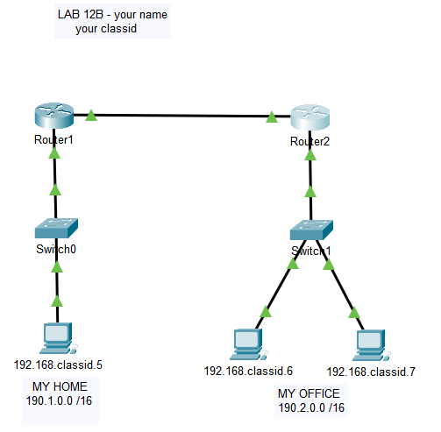

**When complete you should be able to ping from PC5 to PC6 using PC6’s public address.**

**When complete you should be able to ping from PC6 to PC5 using PC5’s public address.**

**Save your PT file as “L12b *lastname*.PKT” and submit in ILearn.**

*\*\*\* End of Lab \*\*\**